Let’s Eat

Ham & Cheese Toastie
Local sourdough bread toasted and filled with ham and cheddar cheese 8

Reuben
Local sourdough bread toasted and filled with corned beef, sauerkraut, swiss cheese and a house made sauce 10

Mediterranean
Local sourdough bread toasted and filled with grilled eggplant, capsicum, sun -dried tomatoes, olives, pesto and mozzarella 10

Acai Bowl
Acai berry puree, bananas, dried fruits and nuts topped with fresh fruit, berries and almond butter 15

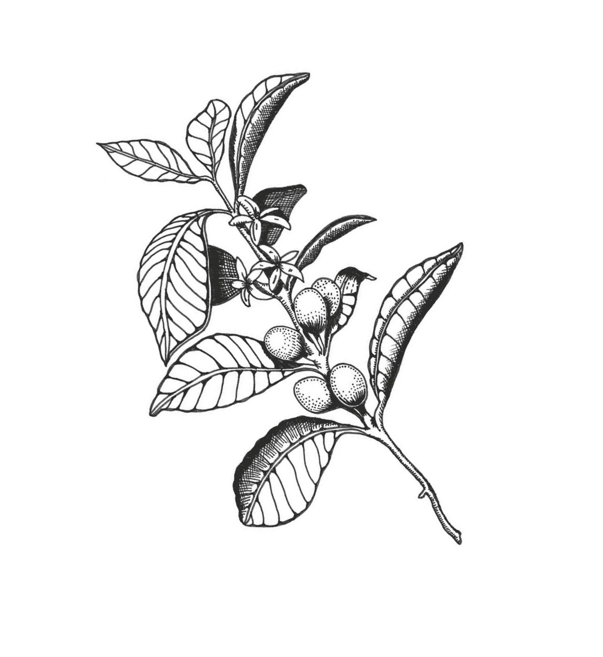

Cacao Ball 3
Almond Butter Ball 3 Caramel Slice 4.5
Hedgehog 4.5
Lemon Slice 4.5
Mars Bar Slice 4.5
Spider 4

